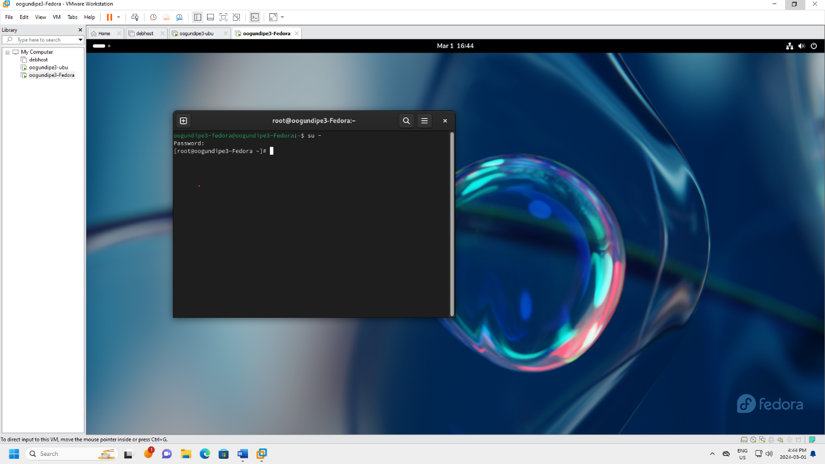

Figure - Can log in as root on chosen OS(Fedora)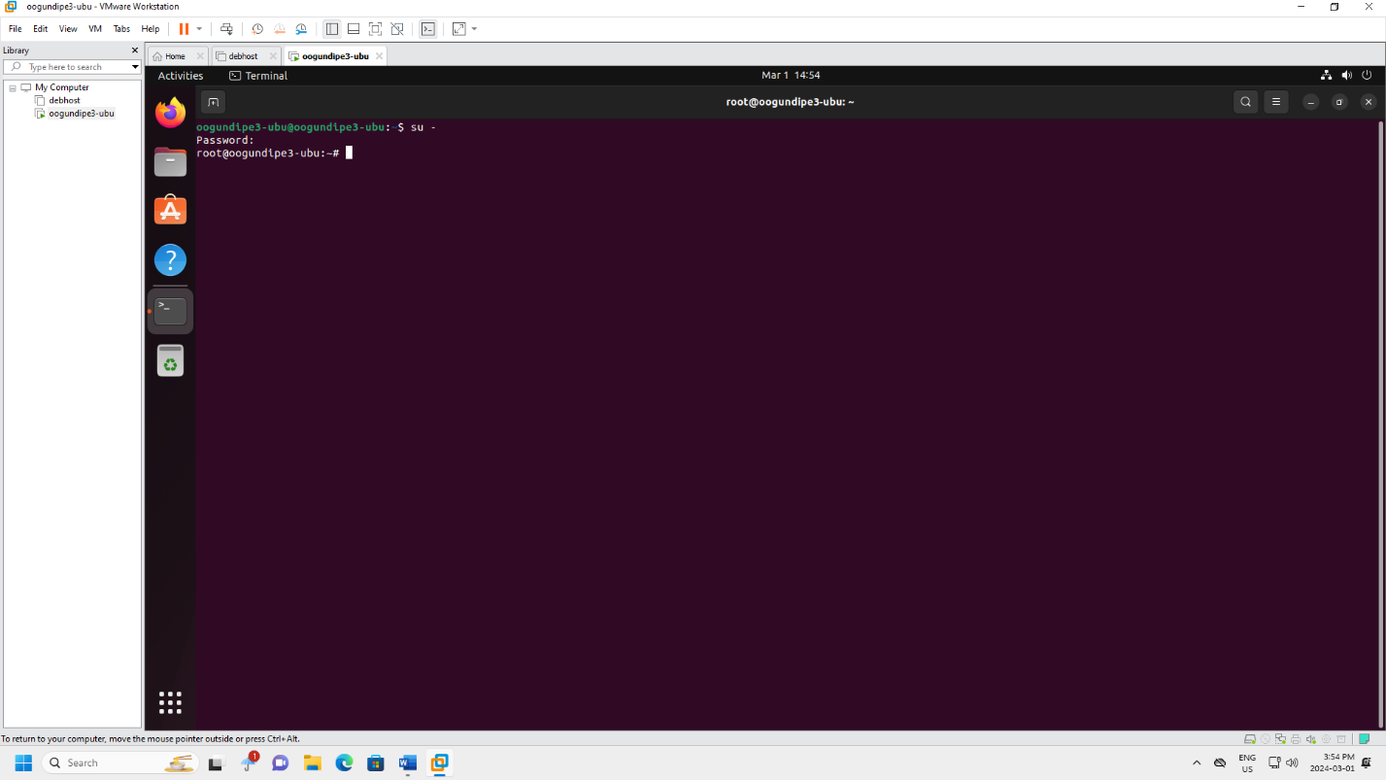

Figure - Can log in as root on Ubuntu

Figure - Chosen Linux OS VM installed (Fedora)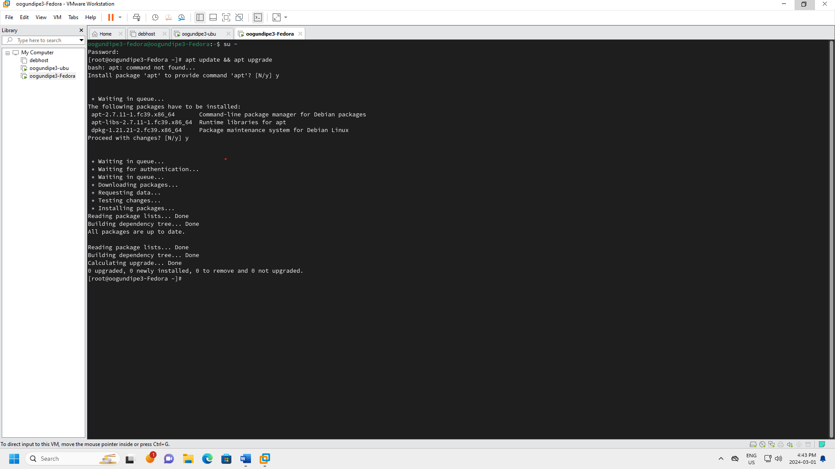

Figure - Chosen Linux OS VM Updated(Fedora)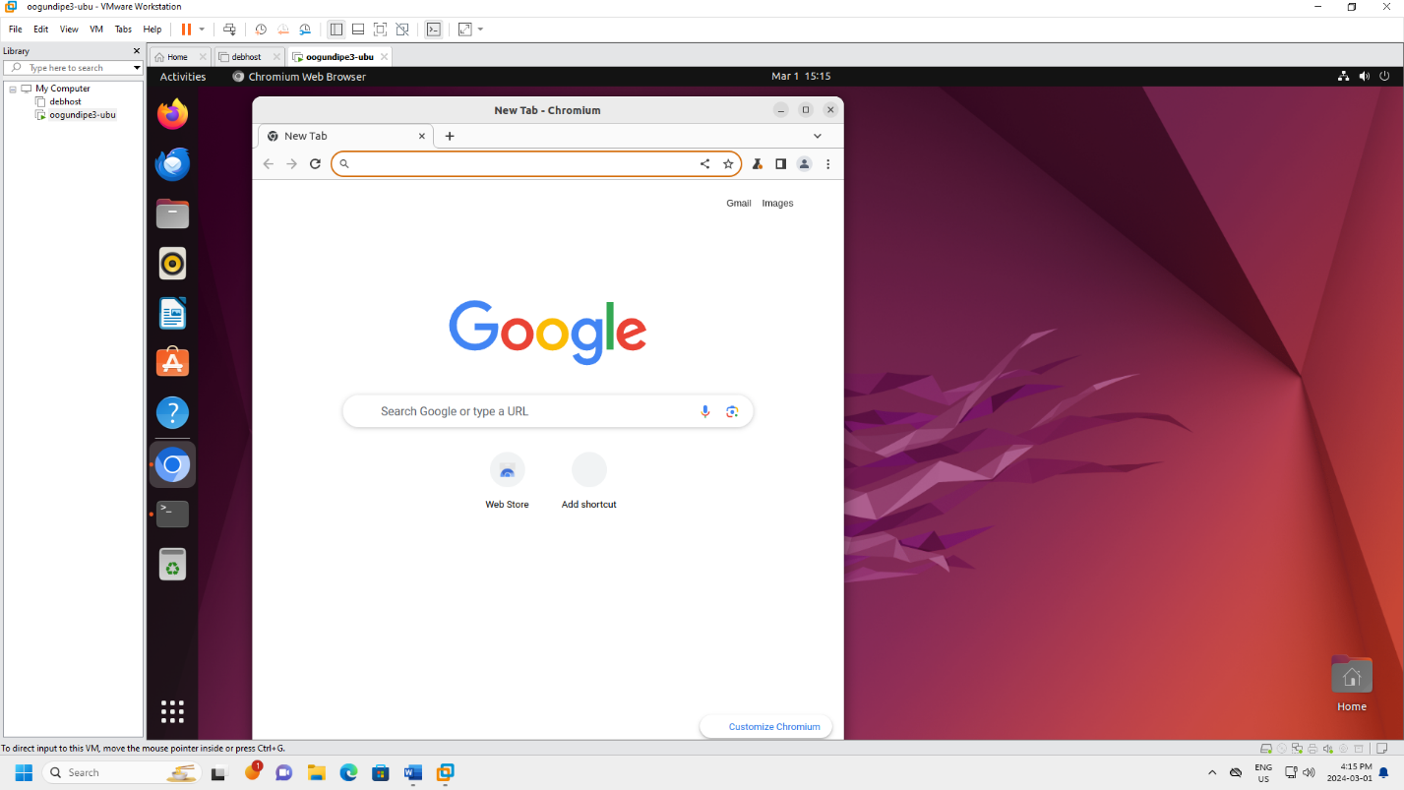

Figure - Chromium installed in Ubuntu VM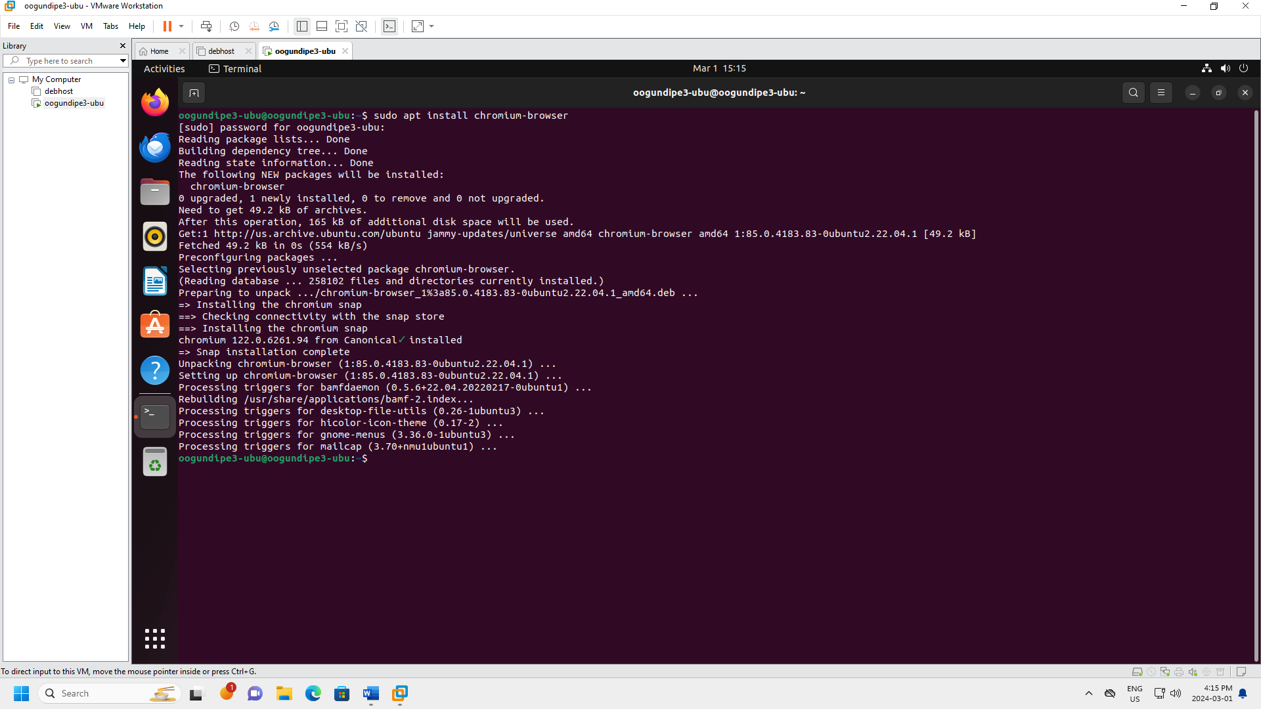

Figure - Chromium intsalled using 'apt'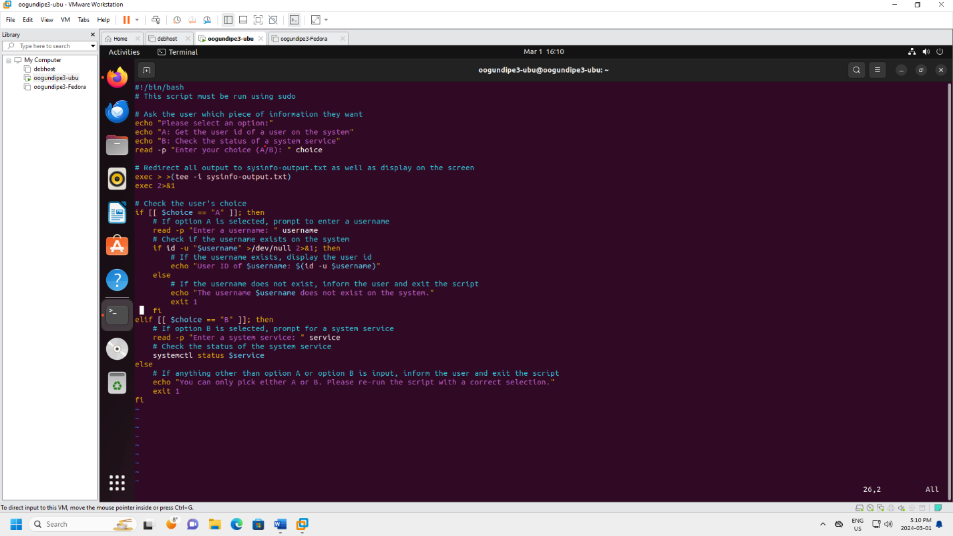

Figure - Contents of Script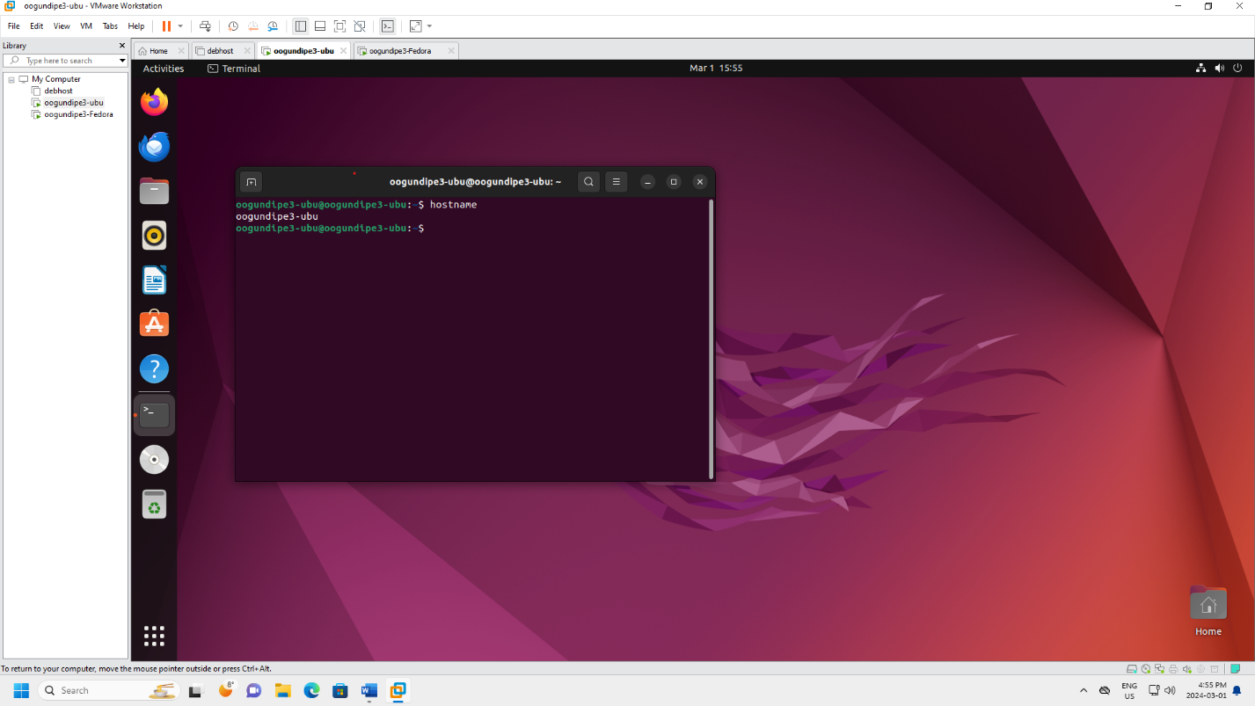

Figure - Correct Hostname (oogundipe3-ubu)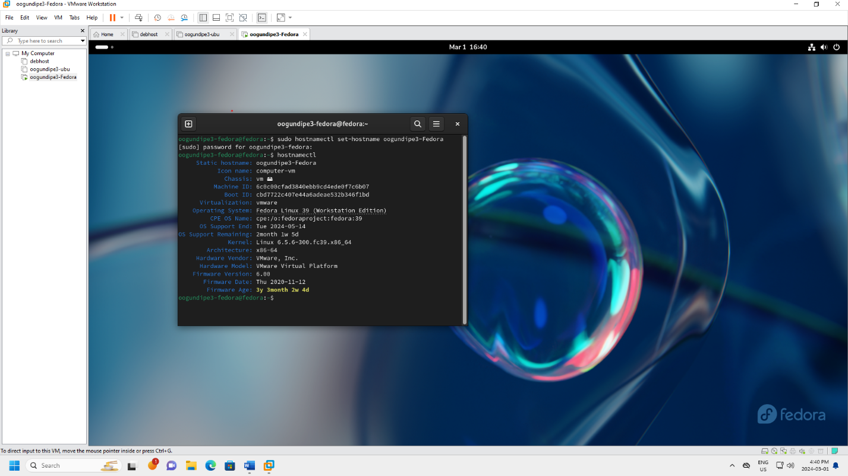

Figure - Correct Hostname(oogundipe3-Fedora)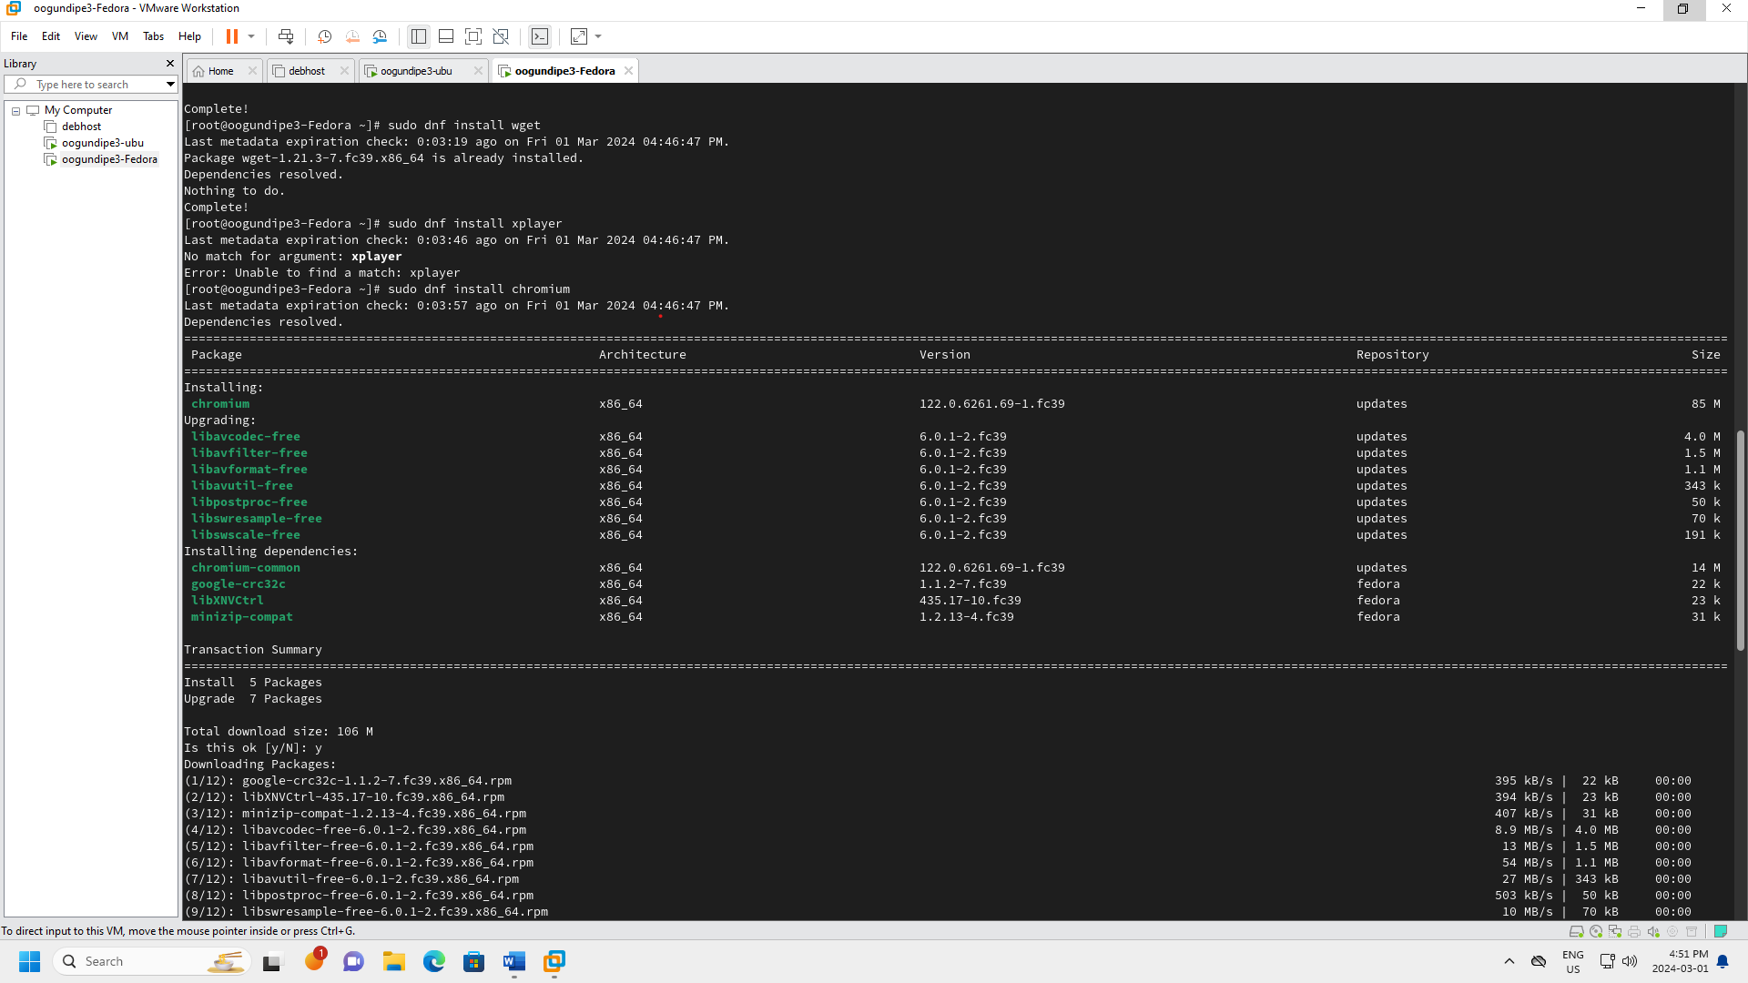

Figure - Install 2 Packages Chromium(1)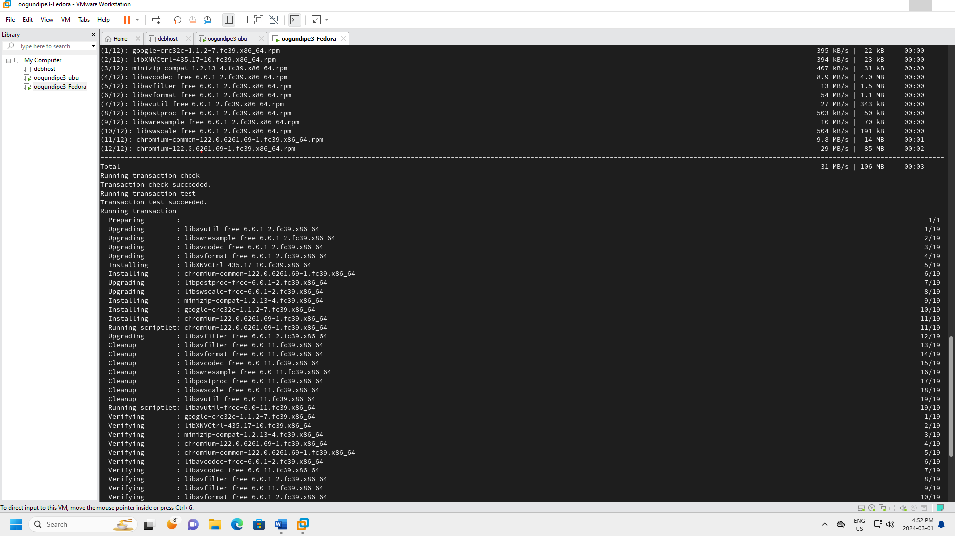

Figure - Install 2 Packages Chromium(2)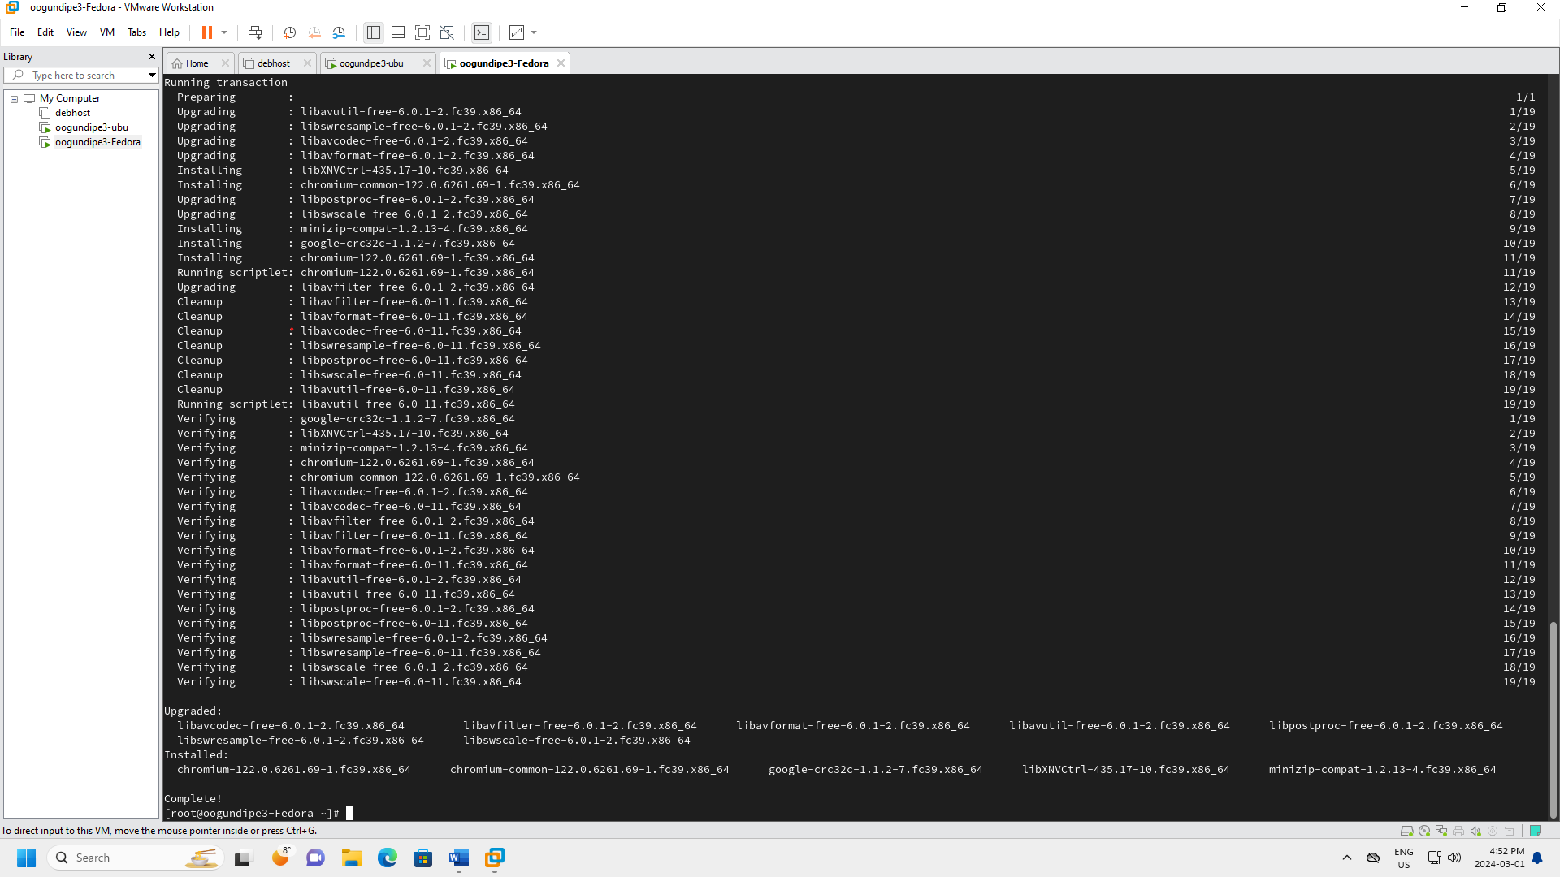

Figure - Install 2 Packages Chromium(3)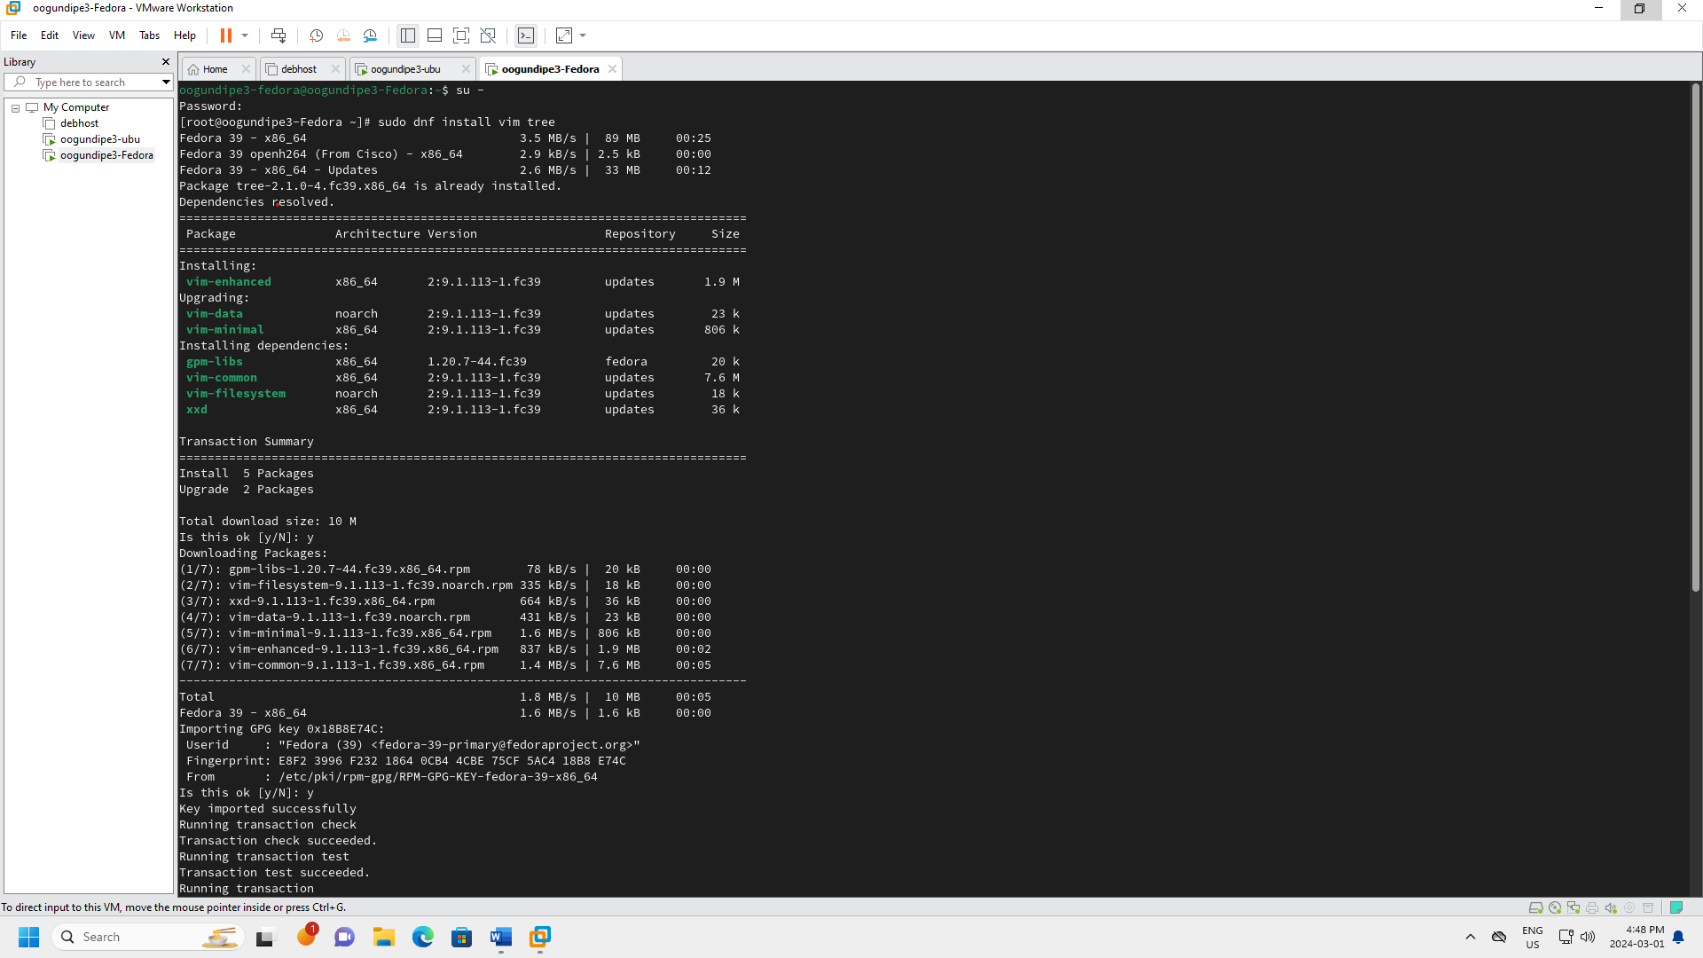

Figure - Install 2 Packages-Vim (1)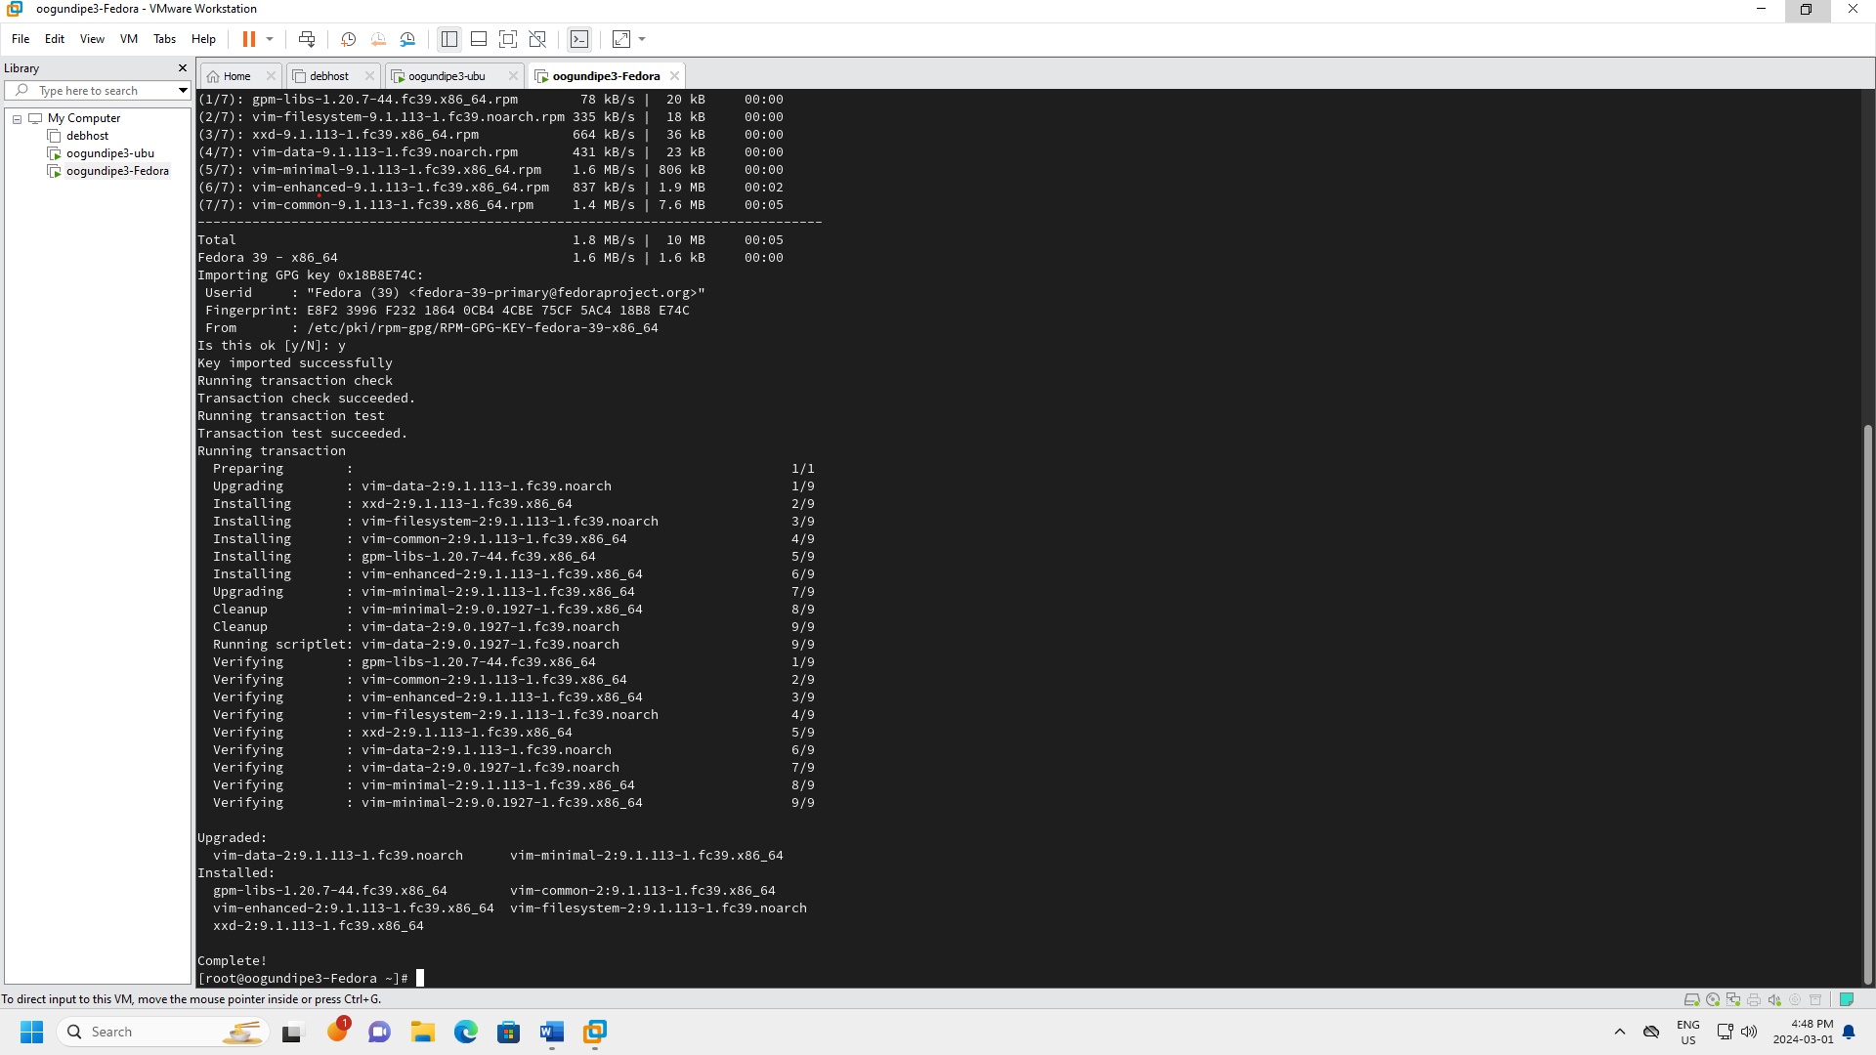

Figure - Install 2 packages-Vim (2)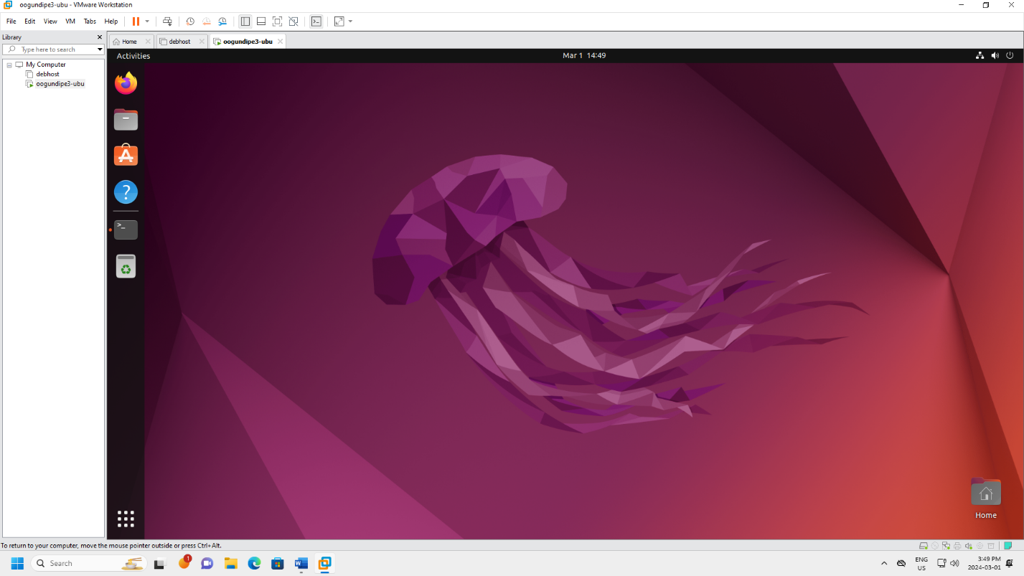

Figure - New Ubuntu VM installed(oogundipe3-ubu)

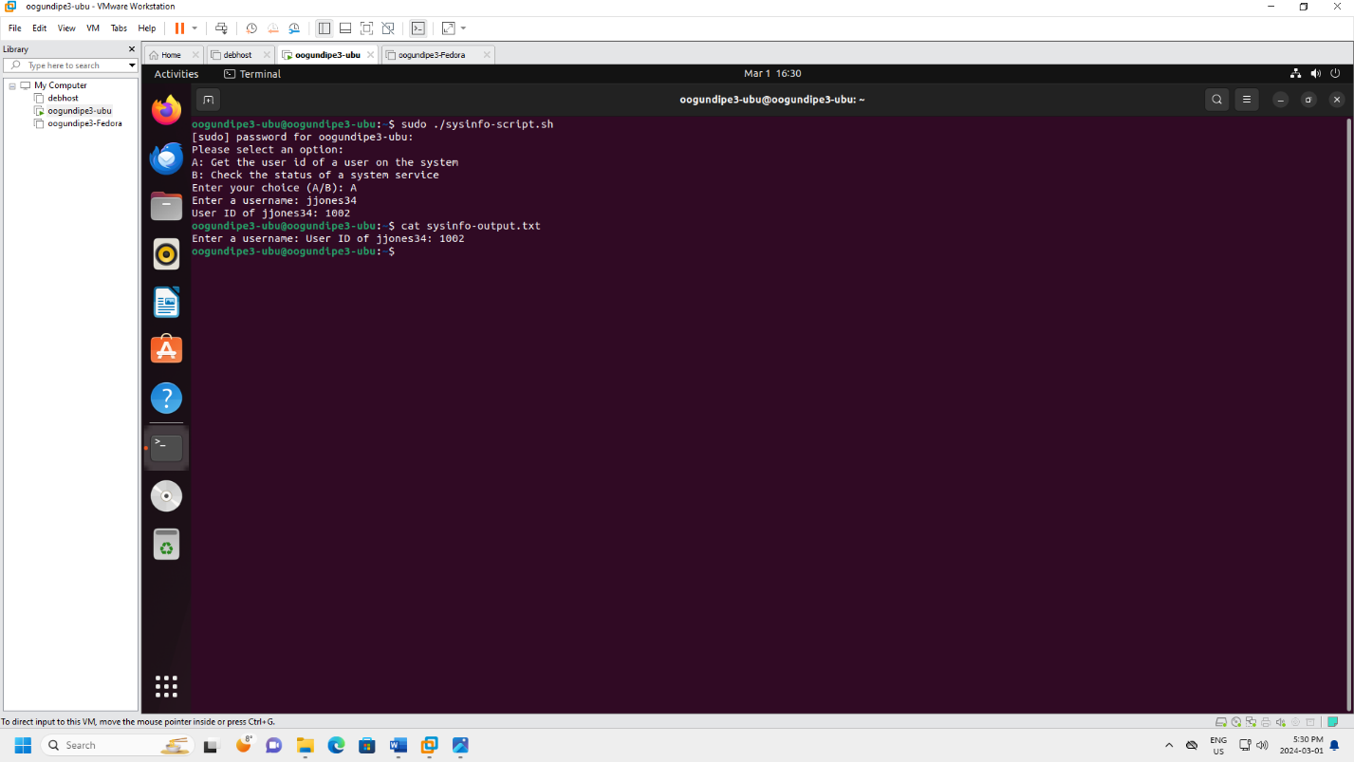

Figure - Bash Script Output 1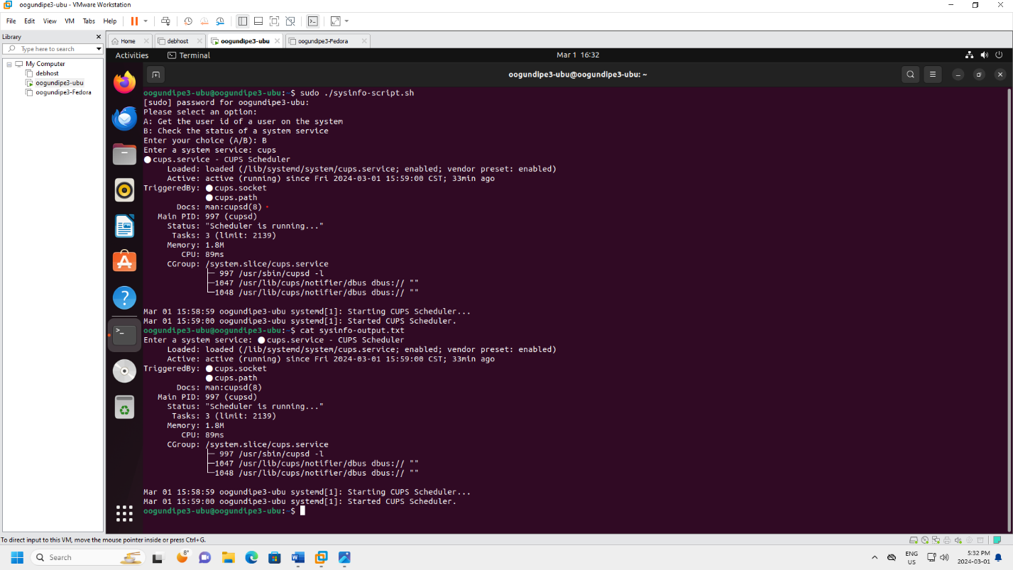

Figure - Bash Script Output 2

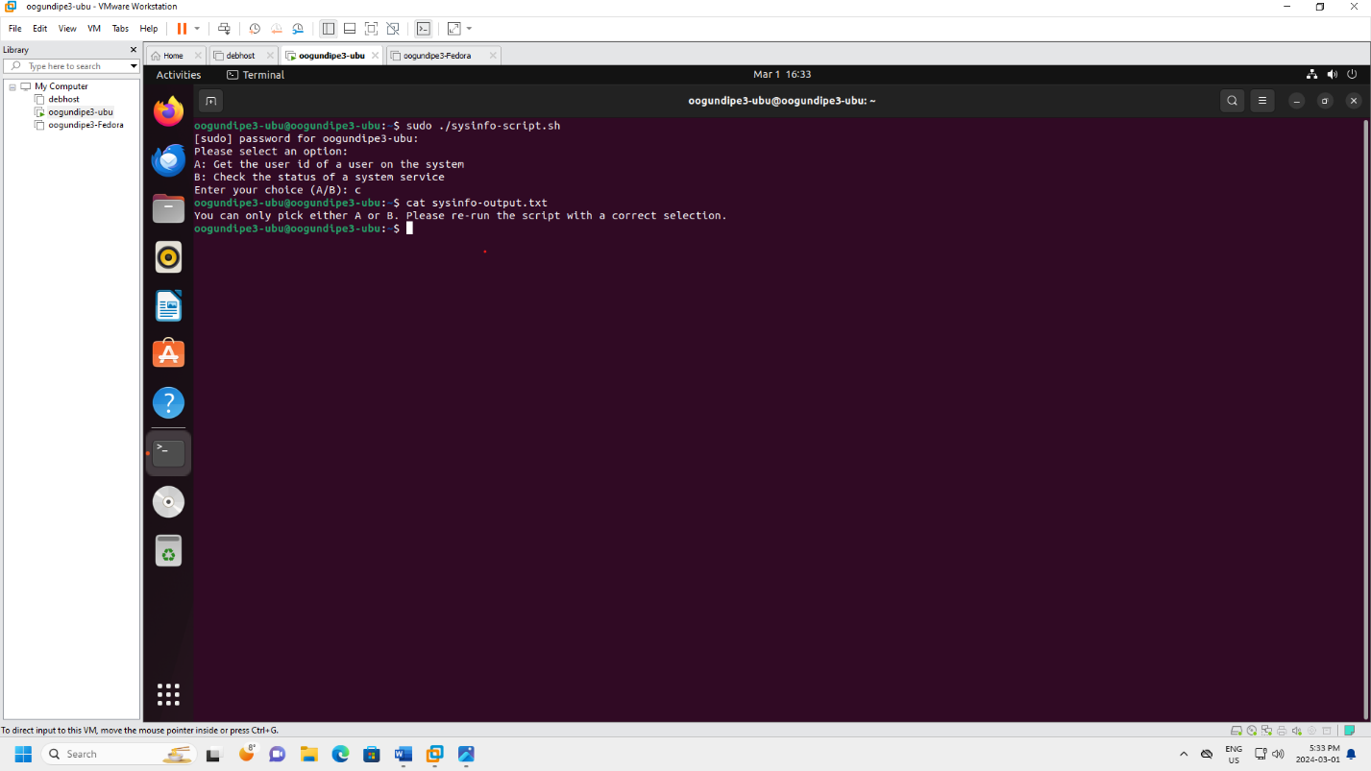

Figure - Bash Script Output 3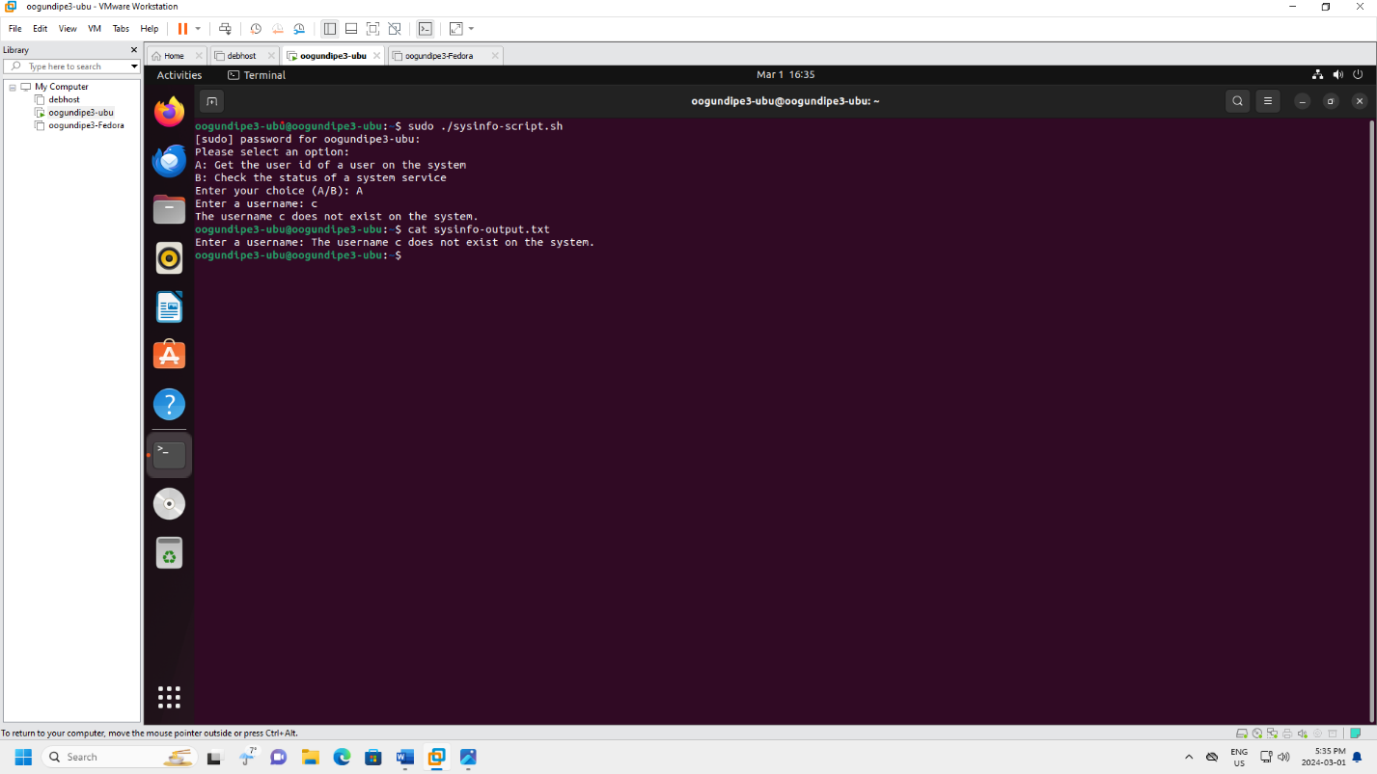

Figure - Bash Script Output 4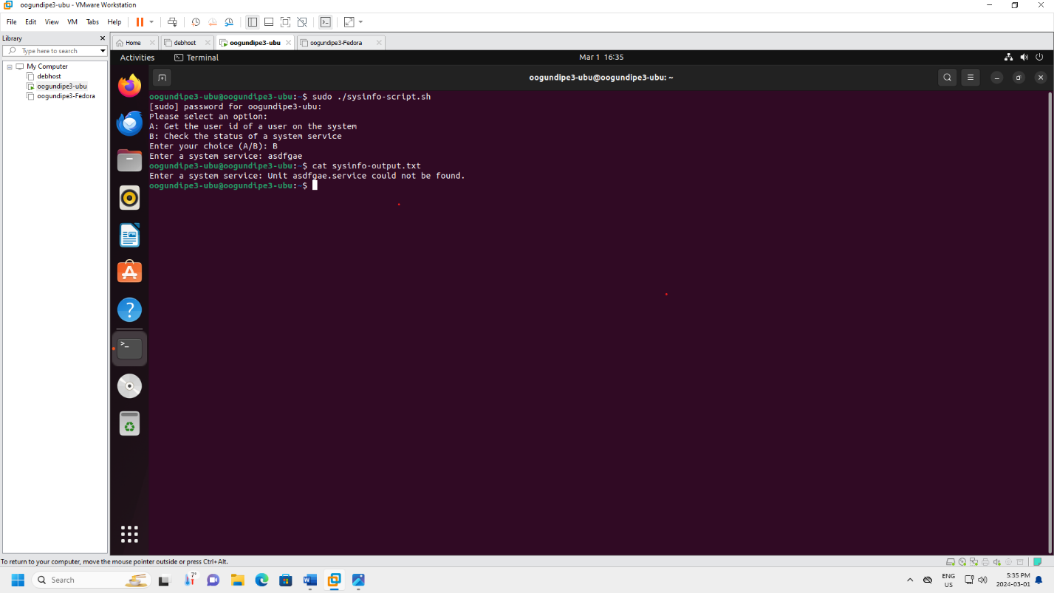

Figure - Bash Script Output 5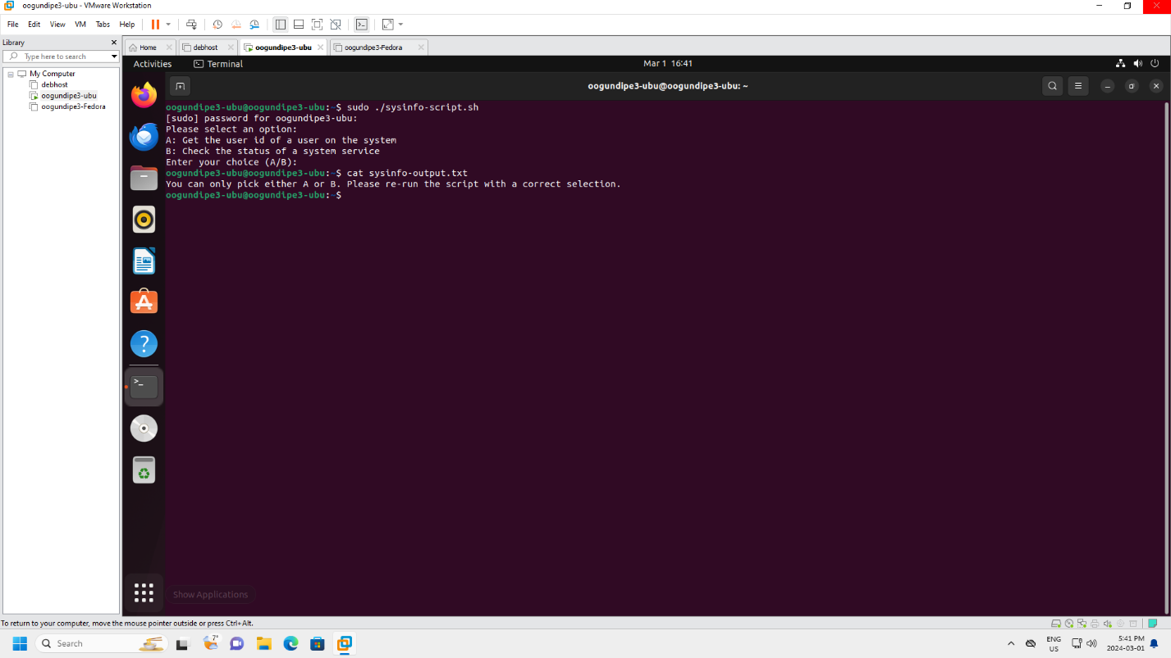

Figure - Bash Script Output 6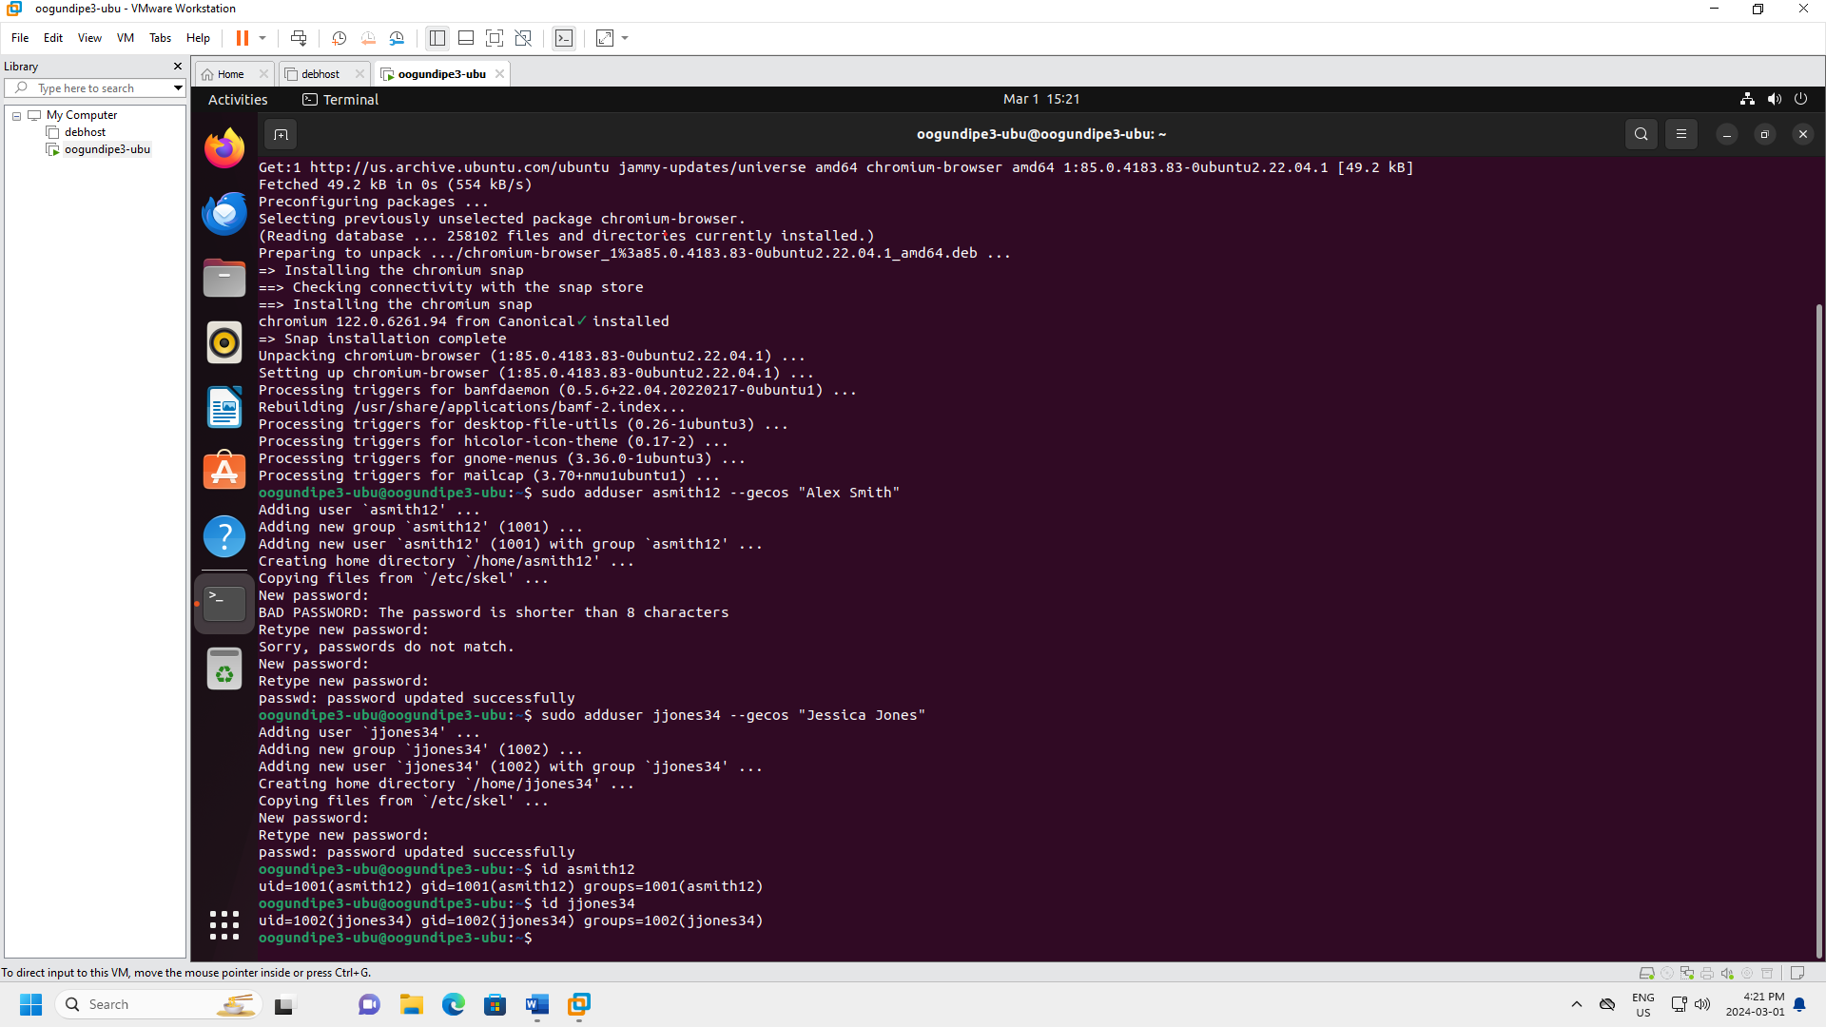

Figure - Two new users added in Ubuntu VM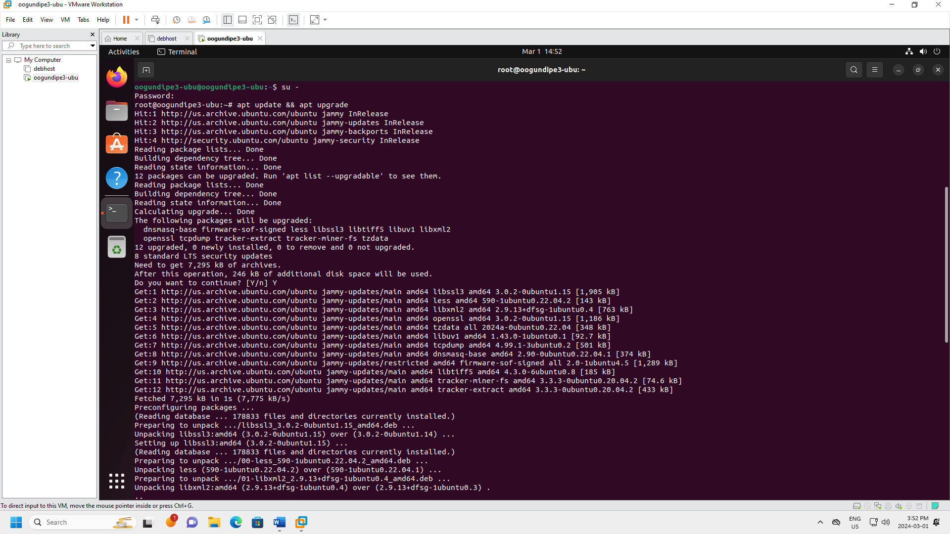

Figure - Ubuntu VM updated(1)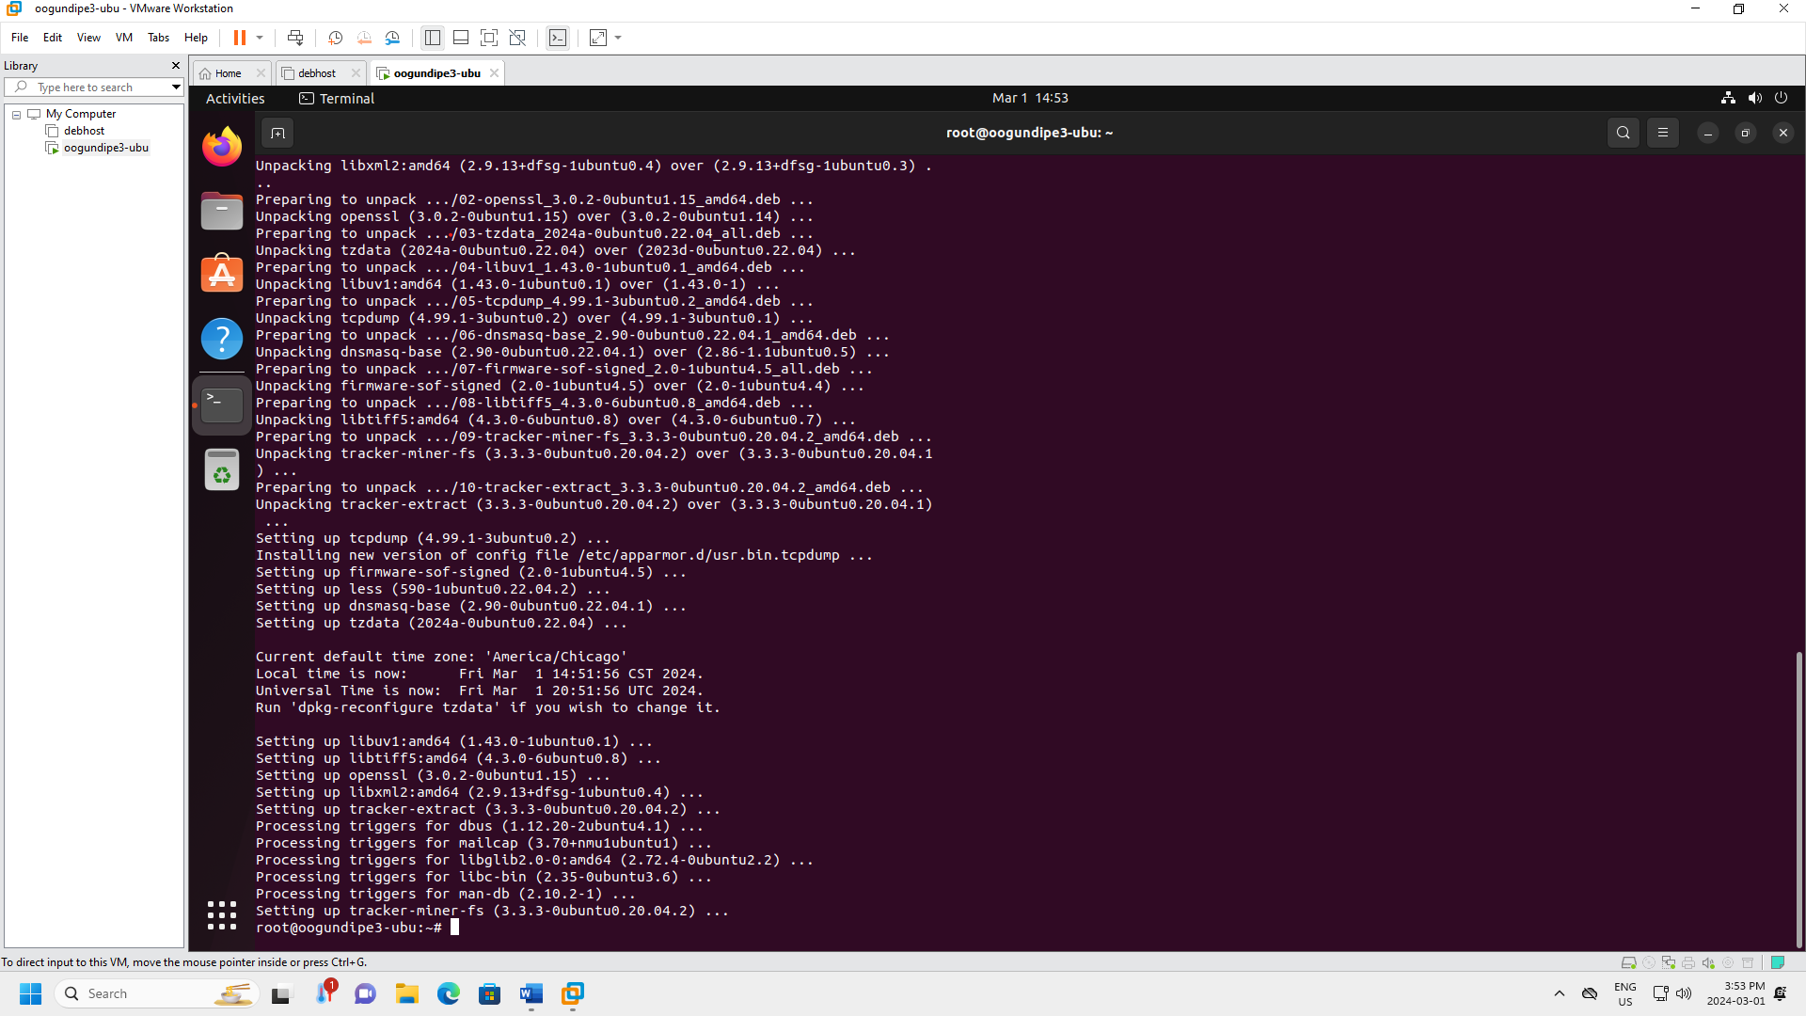

Figure - Ubuntu VM updated (2)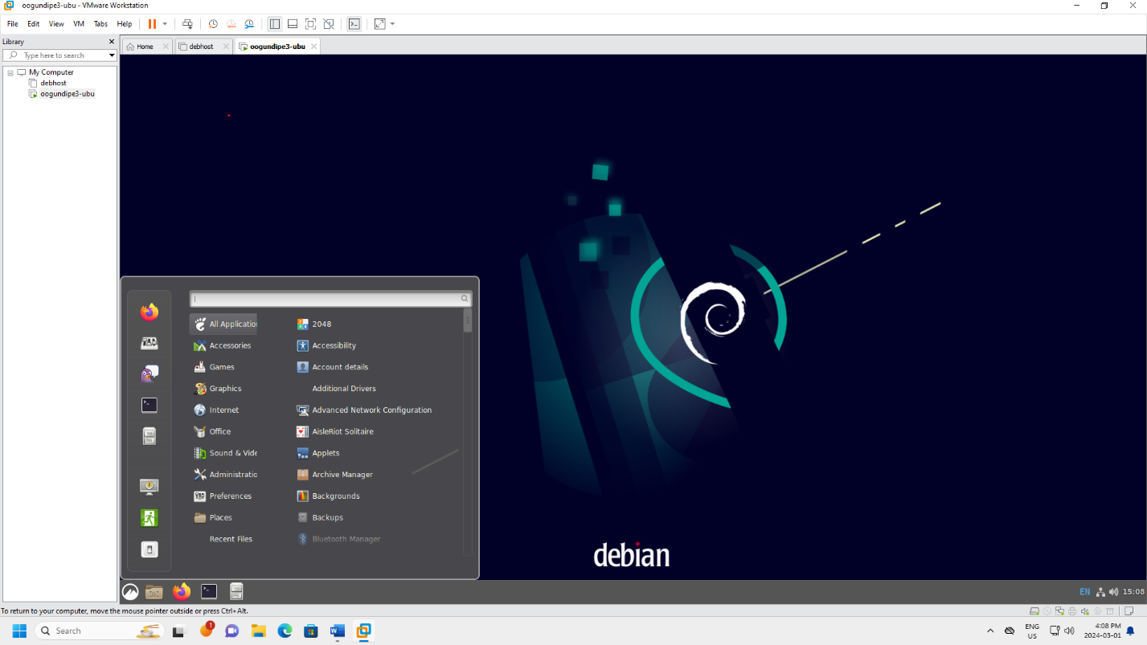

Figure - Ubuntu VM using Cinnamon

***Linux Distribution Write-Up: Fedora***

**Why did you choose this OS?**

I chose Fedora for its cutting-edge technology and strong community support. Fedora is known

for its innovation, often being the first to introduce new features and technologies. It’s a forward-

thinking distribution that isn’t afraid to shake things up, which aligns with my desire to stay on

top of the latest developments in the Linux world.

**What is the purpose of this OS?**

Fedora’s purpose is to provide a free, open-source, and powerful operating system that’s easy to

use. It aims to deliver the latest stable versions of open-source software on a robust foundation.

Fedora is sponsored by Red Hat, one of the world’s most successful open-source companies, and

acts as a testing ground for new technologies that may eventually make their way into Red Hat

Enterprise Linux.

**What sort of user is this OS designed for? How does this OS support such users?**

Fedora is designed for users who prefer a cutting-edge experience, with the latest features and

advancements in open-source software. This includes developers, Linux enthusiasts, and tech-

savvy professionals. Fedora supports these users by providing a robust, innovative, and secure

platform for development and work. It offers a variety of desktop environments, such as

GNOME, KDE, and Xfce, allowing users to choose the one that best suits their needs.

Additionally, its software repositories are vast, ensuring users have access to all the tools they

need.

**What other distributions are similar to this OS and what differentiates this OS from them?**

Other distributions similar to Fedora include Ubuntu, Debian, and openSUSE. However, Fedora

stands out in several ways. Unlike Ubuntu or Debian, Fedora has a strict policy of only including

free software in its repositories. It’s also more bleeding-edge than Debian, which prioritizes

stability. Compared to openSUSE, Fedora releases are more frequent, providing users with the

latest software faster. Lastly, Fedora’s close relationship with Red Hat gives it a unique position

in the enterprise world, making it a popular choice for many businesses and developers.